CS427 Exam 1 Study Guide
Review the lecture slides, and assignments. Below is a list of topics that we have covered. The list is not sorted by importance, just the order in which we covered it in class.

1. Time and Space Complexity
Definition of time and space complexity.
Time Complexity: Describes the efficiency class of an algorithm based on how quickly the complexity grows relative to increasing inputs.
Space Complexity: Refers to the efficiency class of an algorithm based on how many extra stack frames or data structures are used relative to needs of the problem.
Factors affecting time complexity: input size, algorithm structure, operations used, etc.
Big O Notation | Name | Example (Time)
O(1) | Constant | If(conditional)  single statements or conditions
O(log n) | Logarithmic | For(int I; I < n; I / 2)  problem is smaller than n iterations at worst
O(n) | Linear | For(int I: n)  problem has about n iterations at worst
O(n log n) | Linearithmic | A log function nested within a linear function
O(2^n) | Exponential | Return problem(n-1) + problem(n-2)  A problem that utilizes two recursive branches
O(n^2) | Quadratic | A linear function nested within another linear function
O(n!) | Factorial | Generate all permutations of an array list

Factors affecting space complexity: variables, data structures, recursion depth, etc.
Trade-off between time and space complexity.
Big O Notation | Name | Example (Space)
O(1) | Constant | No additional data structures or stack frames used. No recursion.
O(log n) | Logarithmic | Extra recursive stack frames are smaller than the problem size n at worst.
O(n) | Linear | Extra recursive stack frames are of size n at worst.
 | …
O(2^n) | Exponential | Return problem(n-1) + problem(n-2)  A problem that utilizes two recursive branches
 | …

2. Iterative / Non-recursive Algorithms
Definition and examples.
Analysis of loop-based algorithms.
Recognizing patterns in iterative algorithms to determine complexity.

3. Recursive Algorithms
Homogeneous Recursion: Single recursive call, e.g., factorial function.
Uses values of the same type in recursion

T(n) = aT(n/b) + f(n)
Master Theorem:
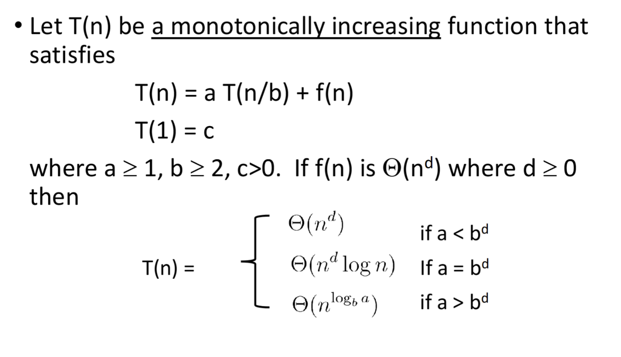
Examples
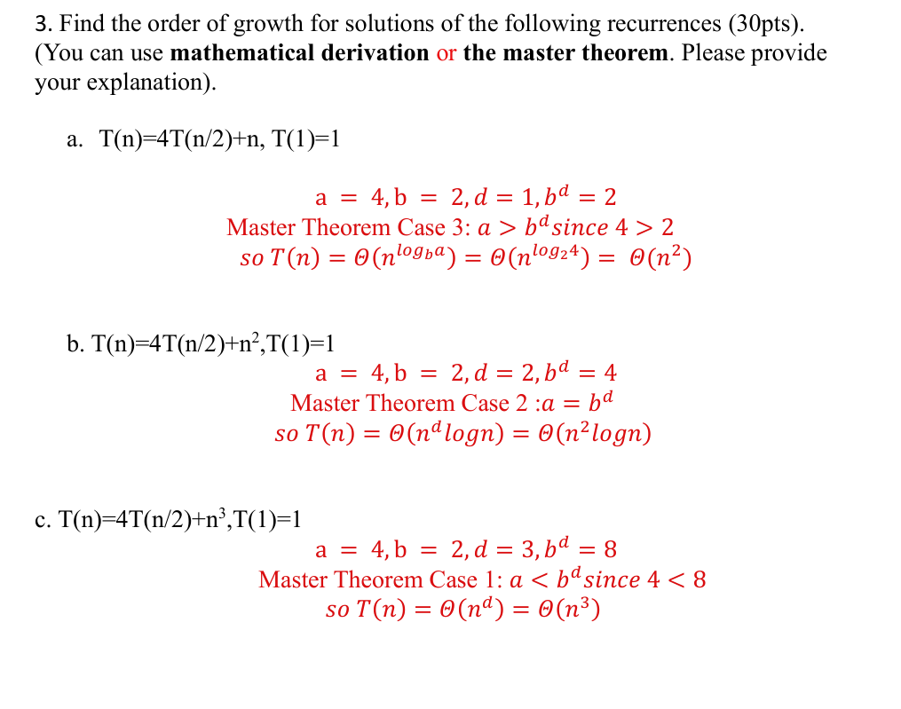

Mathematical Derivation:
Steps:
- Statement
- Recurrence Pattern – plug in the last term into the current term
- Determine recurrence equation
- Solve for base case k = n – b
- Plug base case into pattern equation
- Reduce to dominant term to determine efficiency class
- Conclusion
Suppose the time complexity of an Algorithm A follows the recursion below:
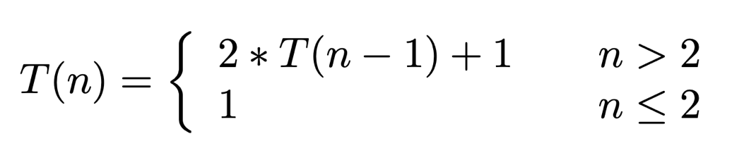
Determine the Big-Theta Θ notation of T(n). (20pts).
Note: You may want to review your slides.
(Statement (5pts), Prove (10pts), Conclusion (5pts).)

We claim that T(n) will grow exponentially.
Starting from n, the sequence for T(n) based on the relation looks something like:

$$T\left(n\right)= 2*T\left(n-1\right)+ 1$$
$$T\left(n\right)=2*\left( 2*T\left(n-1\right)+ 1\right)+1=2^{2}*T\left(n-2\right)+3$$
$$T(n)=2*\left(2^{2}*T\left(n-2\right)+3\right)+1=2^{3}*T\left(n-3\right)+7$$
$$T\left(n\right)=2*\left(2^{3}*T\left(n-3\right)+7\right)+1=2^{4}*T\left(n-4\right)+15$$
And so on.
It appears that the series follows a pattern. In general, after k expansions, it appears that:

$$T\left(n\right)= 2^{k}*T\left(n-k\right)+2^{k}-1$$

We know T(2) = 1, so
$$n-k=2$$
$$k=n-2$$

If we plug value of k into the equation, we get

$$T\left(n\right)= 2^{n-2}*T\left(n-(n-2)\right)+2^{n-2}-1$$
$$T\left(n\right)=2^{n-2}*T\left(2\right)+2^{n-2}-1$$
$$T\left(n\right)=2^{n-2}(1)+2^{n-2}-1$$
$$T\left(n\right)=2^{n-1}-1$$

Thus, our algorithm’s time complexity T(n) grows on average by $(2^{n})$ since that is our dominating factor.

Understanding the base case and the recursive case.
Base Case: The most reduced step – used repeatedly to build upon each other recursive steps
Recursive Case: Repeatedly uses the base case in an operation
Visualizing recursion using recursion trees.
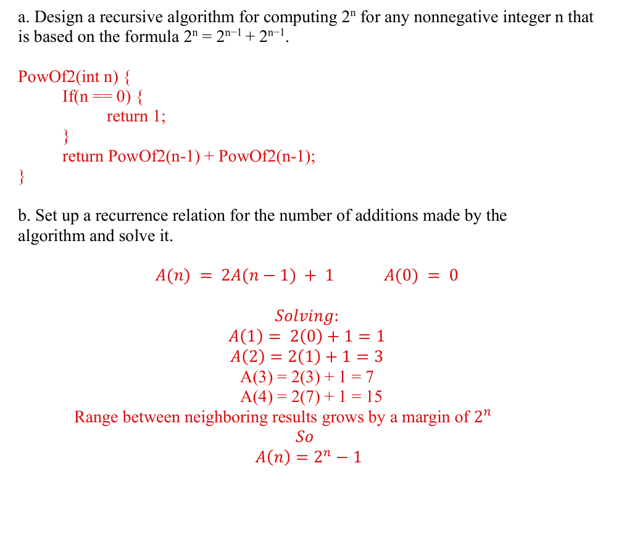
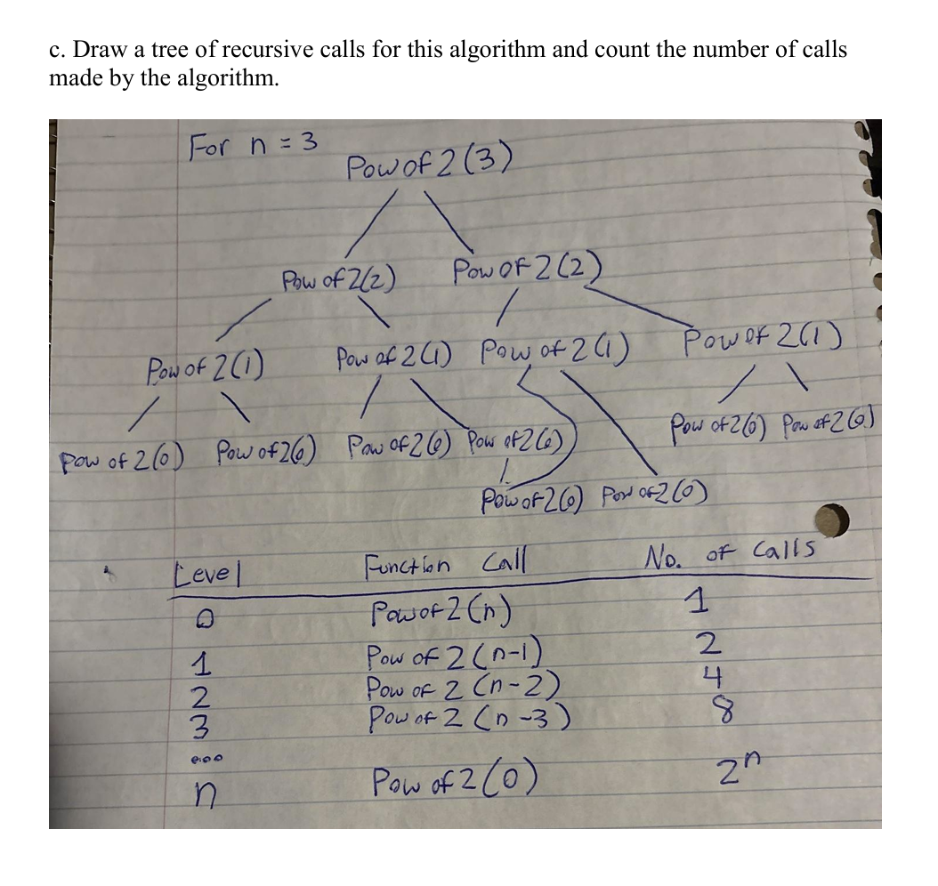

4. Insertion Sort
Understand the basic principle: sort one element at a time.

Algorithm steps and pseudocode.
/* Function to sort array using insertion sort */
void insertionSort(int arr[], int n)
{
for (int i = 1; i < n; ++i) {
int key = arr[i];
int j = i - 1;

/* Move elements of arr[0..i-1], that are
greater than key, to one position ahead
of their current position */
while (j >= 0 && arr[j] > key) {
arr[j + 1] = arr[j];
j = j - 1;
}
arr[j + 1] = key;
}
}
Best-case, worst-case, and average-case time complexities: O(n), O(n^2), and O(n^2) respectively.
Space complexity: O(1).
Visualize using examples.
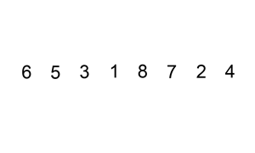

5. Decrease-by-a-constant factor algorithms
Principles and characteristics.
Reduce by a constant factor at each step
Top-down & Bottom-up
Top Down (Recursive)
- Start with the original problem and move recursively solve smaller subproblems
- Function to call itself with reduced input size
- Mirrors mathematical recurrence
- Function call overhead – possible stack overflow
Bottom Up (Iterative)
- Start from smallest subproblem to solve original the larger problem
- Use loops or tables
- Avoid recursive overhead
- Uses more variables
Examples: binary search, quicksort (though the full study of quicksort might be covered later in the course).

6. Binary Search
Prerequisite: The list must be sorted.
Understand the principle: Divide the list in half repeatedly until the desired element is found.
Steps and pseudocode.

class Solution {
public int searchInsert(int[] nums, int target) {
int high = nums.length-1;
int low = 0;

while(low <= high) {
int mid = (low + high) / 2;
System.out.print(mid);
if(nums[mid] == target) {
return mid;
} else if(nums[mid] < target) {
low = mid + 1;
} else {
high = mid - 1;
}
}
return low;
}
}

Time complexity: O(log n).
Space complexity: O(1) for iterative version, O(log n) for recursive version due to call stack depth.

Compare with linear search. Linear search is less efficient because you must, at worst, search every element in the list. With binary search, you can reduce the number of possible answers in half each check which will have a check less than n.

For the Fibomacci Numbers
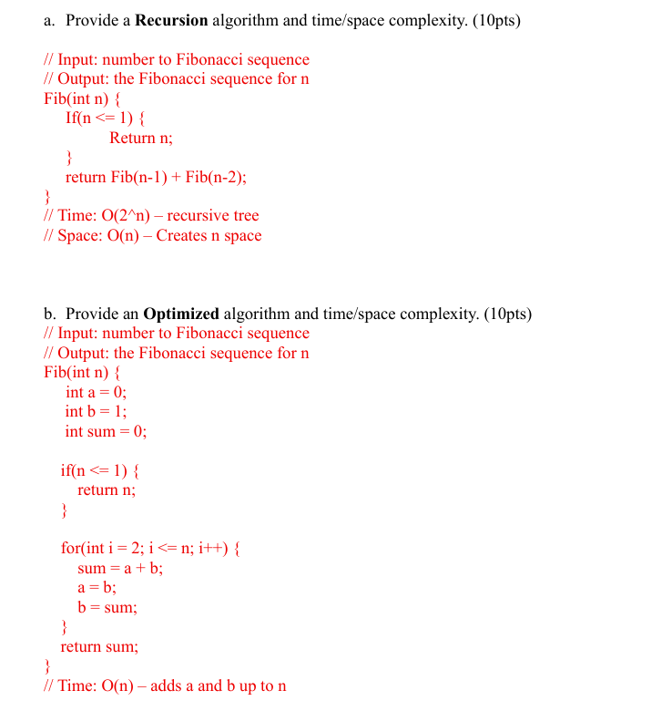
Two Sum
class Solution {
public int[] twoSum(int[] nums, int target) {
// key = number, value = its index
HashMap<Integer, Integer> mem = new HashMap<>();

for (int i = 0; i < nums.length; i++) {
// The desired difference between the current number and the target
int gap = target - nums[i];

// check if we've already seen the desired number
if (mem.containsKey(gap)) {
// return the pair
return new int[]{i, i-1};
}
// store the current number with its index
mem.put(nums[i], i);
}
return new int[]{-1,-1};

}
}

